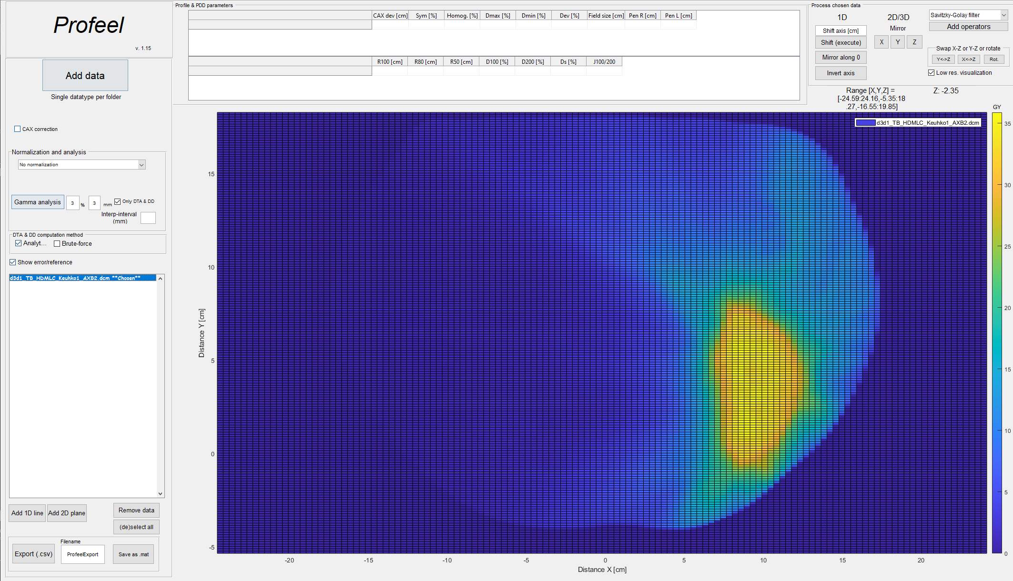

Instructions fOR use

Profeel v. 1.15

14. December 2020

Tomppa Pakarinen

Contents

Tooltips 2

Importing data 2

Data truncation during import 2

Normalization and interpolation during the import 2

CAX correction checkbox (not recommended) 2

Presenting and removing the data 3

Extracting lower dimension data 4

Quick profile tool 4

Data normalization 6

Profile- and PDD parameters 7

Assigning computed parameters 7

Processing tools 7

1D 8

2D and 3D processing 8

Adding custom operators 8

Gamma, DTA and DD 10

Passing criteria 10

Gamma computation resolution (interp-interval) 10

Isodose limit 10

Performing a gamma, DTA and DD analysis 11

Saving the data and results 11

# Tooltips

Tooltips are supported in this program. Tooltips are revealed by hovering the cursor above the given UI object.

# Importing data

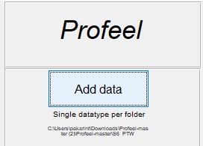

***Figure 1.*** *Add data button*

Data can be imported by clicking the ‘Add data’ button. Chosen data folder **must** contain only a single data type (may contain multiple files). Different datatypes can be opened by repeating the same process. The supported data types are currently:

* .mcc
* Omnipro exports (.OmmiIMRT, .opg)
* PTW exports (.txt)
* .3ddose files
* DICOM RT files

The latest chosen path will be shown under the UI data button. Imported data will be appended to the UI listbox.

## Data truncation during import

2D and 3D Data resolution will be automatically truncated (new data structure is created) if the resolution exceeds a given threshold. Truncated data is used to speed up 2D and 3D visualization and as default resolution for gamma, DTA and DD computation.

## Normalization and interpolation during the import

Different normalizations are computed during data import. For 1D data all possible normalizations are computed. Failed computations will be printed to the terminal. Data will be also linearly interpolated with x10 of original resolution. Interpolated data will not be displayed in the program but is used in profile and PPD parameter computation.

## CAX correction checkbox (not recommended)

Central axis (CAX) is corrected for the profile data only during import, if the checkbox is checked. The correction will not be visualized but is used in processing. **Preferred method is to import the data without the CAX correction** and if necessary, correct the CAX using shift operator by the amount of CAX deviation (profile parameter). CAX correction checkbox will be modified in future version.

# Presenting and removing the data

Imported data is found in the GUI list box (figure 3). Listbox members are activated for processing and displayed in the UI figure by choosing them from the listbox. Multiple files can be activated simultaneously. Chosen data shows as bolted and the word ‘Chosen’ is added in the end of the file name.

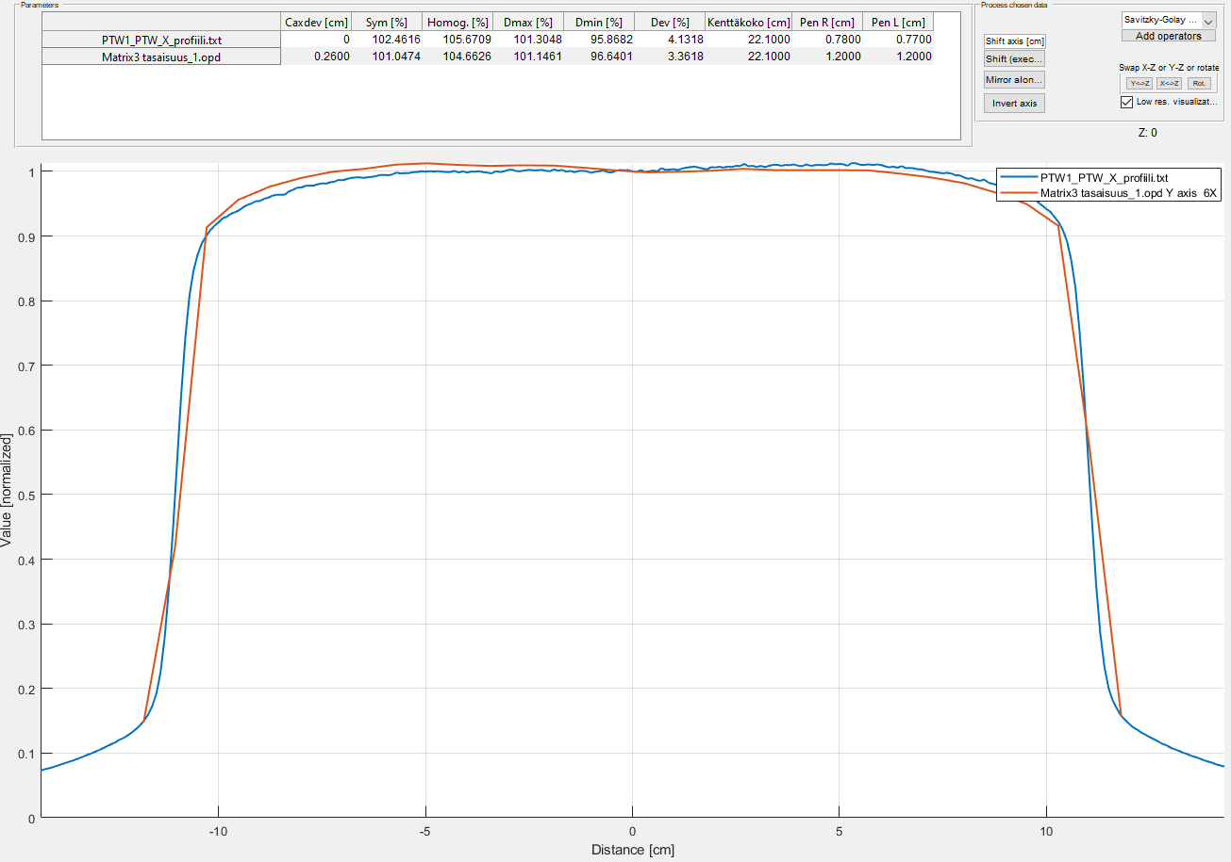All activated data is visualized in the main GUI figure.

***Figure 2.*** *Main UI figure with example 1D data*

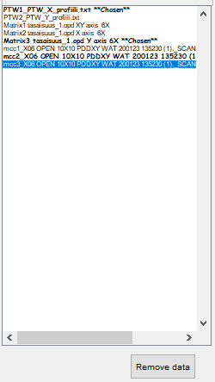Data is unchosen by re-clicking it.

***Figure 3.*** *Imported data will appear to the UI list box*

Data can be removed from the program by using the ‘remove data’ -button, placed under the list box. Button affects all chosen data.

# Extracting lower dimension data

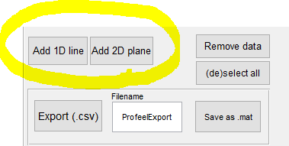Lower dimensions can be extracted from higher dimension data. i.e. 1D line profiles and 2D planes can be extracted from 3D data and 1D line profiles from 2D data. Extraction is performed from the add line/plane -buttons.

***Figure 4.*** *Extracting lower dimension data button locations*

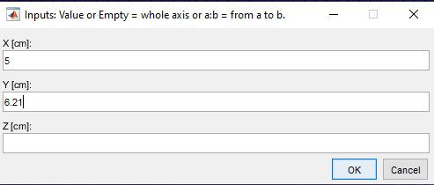Before extraction of 2D planes, the extracted plane and the plane depth are defined. For 1D extracted axes are defined and optionally the range.

***Figure 5.*** *1D profile extraction from 3D dicom RT-file*

Note that leaving the extracted axis empty, the whole axis will be extracted. Extracted range is chosen with syntax a:b, where a and b correspond to the range limits. Profile and PDD parameters are automatically computed for extracted 1D data.

*Note 1 . If the requested 2D plane depth does not exist in the data, the plane will be interpolated from the requested position.*

*Note 2. For 1D planes, data is extracted from the nearest existing point in the data structure’s x10 interpolated data. The extracted positions will be added to the filename.*

## Quick profile tool

1D line profiles can be interactively previewed by using the quick profile tool

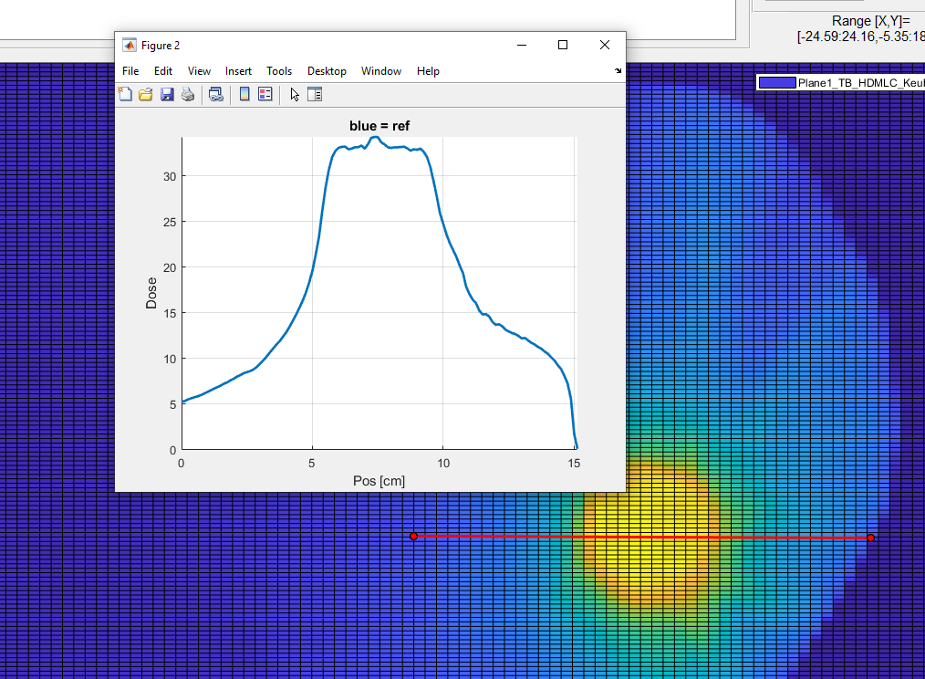

***Figure 6.*** *Quick profile can be dragged and rotated*

Quick profiles can also be used to inspect Gamma, DTA and DD results.

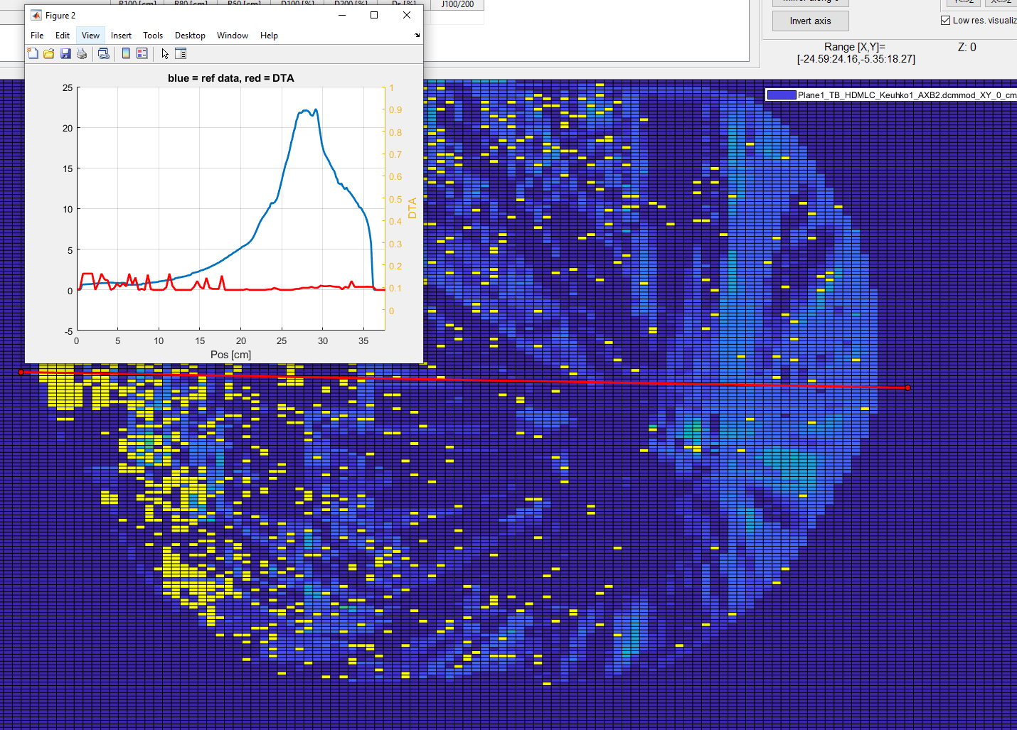

***Figure 7.*** *Quick profile from DTA 2D result. DTA and dose profiles are shown in the same figure*

# Data normalization

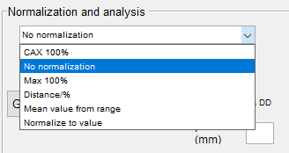Data can be normalized in multiple different ways. Choose proper normalization from the drop box under Normalization and analysis panel.

***Figure 8.*** *Normalization options*

* ‘No normalization’ is the default option
* ‘CAX normalization’ normalizes the data to the central axis (0-position). Only for 1D profiles
* ‘Max 100%’ normalizes the data to the maximum value found in the data
* ‘Distance/%’ normalizes the set axis point (distance) to the set percentage
* ‘Mean value from range’ normalizes the data to the mean value of a given range
* ‘Normalize to value’ normalizes the data (100%) to a set value

# Profile- and PDD parameters

The program tries automatically to separate profile and PDD (1D only). Corresponding parameters are computed and presented in the UI. Parameters are computed based on IEC recommendations.

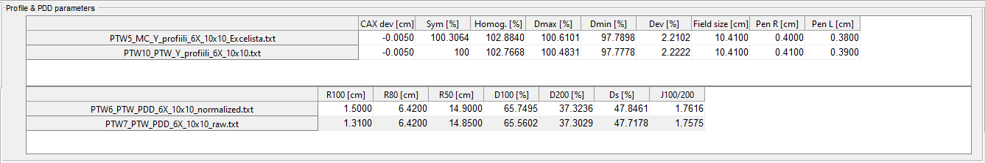

***Figure 9.*** *Profile and PDD parameters*

Profile parameters:

* CAX dev [cm] = Offset between computed CAX and data position axis
* Sym [%] = Symmetry is defined inside the flattened region as
* Homog. [%] = Homogeneity is the relative max-min dose -deviation within the flattened region
* Dmax [%] = Maximum dose
* Dmin [%] = Minimum dose
* Dev [%] = Dose deviation between CAX and the minimum dose within the flattened region
* Fieldsize [cm] = Fieldsize is 50% dose value from the central axis
* Pen R & PenL [cm] = Distance between the 80%-20% dose values
* Flattened region is defined (IEC) for fieldsizes >= 5cm. For smaller fields the program computes the flattened region as for 5cm <= fieldsize <= 10cm.

PDD parameters:

* R100, R80, R50 [cm] = 100 %, 80 % and 50 % dose depths from the surface
* D100, D200 [%] = Relative doses at depths of 10 and 20 cm from the surface
* Ds [%] = Surface dose relative to the maximum
* J100/200 = Quality parameter, ratio between doses at 10 and 20 cm

## Assigning computed parameters

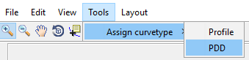If the automatic profile/PDD recognition fails, data can be assigned as profile or PDD from tool bar menu. Profile/PDD parameters are re-computed automatically.

***Figure 10.*** *Assigning the curve type manually*

# Processing tools

Data can be processed with basic processing tools found under the data processing UI panel. All chosen data will be processed.

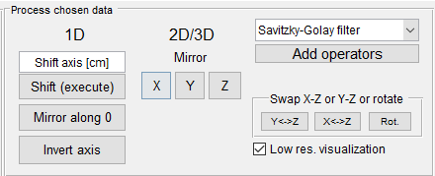

***Figure 11.*** *Processing options for 1D, 2D and 3D data*

## 1D

1D data is shifted along the position axis by inserting the shift length in cm to the edit box. Shift is executed from the Shift-button. Data position axis is updated to the data structure.

Data can be mirrored either along the 0-axis point (includes axis shift) or axis can be inverted

Data can be filtered by using Savitzky-Golay smoothing filter. Using the filter requires the user to set the polynomial order and frame length (must be larger or equal to the order).

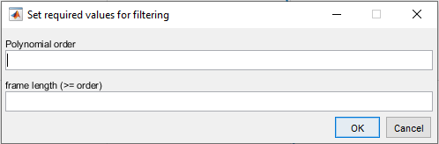

***Figure 12.*** *Savitzky-Golay pop-up window*

Processing is always executed for each existing data normalization and to the interpolated data saved in the data structure.

## 2D and 3D processing

### Data can be mirrored (axis inverted) in each dimension.

### Savitzky-Golay filtering is applicable also for 2D data.

* 2D and 3D data can be manually scaled
* Original resolution can be displayed by unchecking the ‘’low res. Visualization” button.
* 3D data plane can be changed by clicking the “Y<->Z”, “X<->Z” or “Rot.” buttons. Two first buttons will swap the chosen axes, which corresponds to 3D rotation: E.g., “Y<->Z” will swap the displayed (default) Y-axis to Z-axis, i.e., XZ plane is displayed.

Rot. -button will rotate the displayed plane along the 3rd axis. Note that position axes are always presented in ascending order, regardless of the data orientation!

## Adding custom operators

All data can be processed with custom made operators.

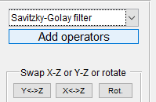***Figure 13.*** *Add operators button location*

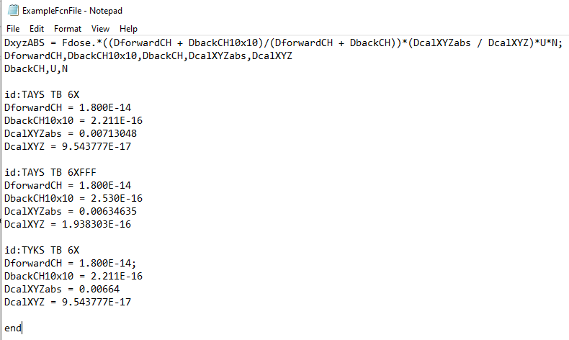Clicking ‘Add operators’ button will open a file browser. Choose a custom made .txt function file, containing the processing instructions. Function.txt files should contain the processing instructions as presented in the example file:

***Figure 14.*** *Example file for creating a custom data processing function*

* 1st line should include the function, operating the data. The program evaluates the function directly -> Use Matlab syntax!
* 2nd line contains the predefined variable names.
* 3rd line contains the variables, which will be prompted. Also, data unit will be prompted by default
* Lines starting with ‘id: name’ will be interpreted as ids for different variable sets. All variable in the 2nd line should be defined under the id. There is no maximum limit for different variable sets (ids). All id’s are added to a dropdown menu as shown in the figure 15 for the example file

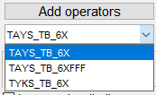

***Figure 15.*** *Variable set id list*

Choosing e.g. “TAYS_TB_6X” would use variables under this id, while evaluating the function in the 1st line.

Use end -keyword to terminate the file.

Function files should be in the same folder as Profeel.m.

# Gamma, DTA and DD

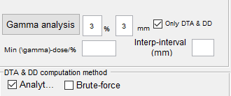Distance to agreement (DTA) is computed for 1D and 2D data by searching the nearest point with same dose between two dose distributions (reference and target). DTA is computed either using interpolation and a threshold value (‘brute force’), or by finding dose points crossing the reference line/plane and solving the DTA at the cross section (‘analytical’). Dose difference (DD) is computed as an absolute value for each data point (subtraction) and as relative value to the reference data. Passing criteria, computation resolution and isodose limit can be modified by the user.

***Figure 16.*** *Gamma, DTA and DD analysis tools*

Gamma computation is performed by minimizing the squared sum of the gamma components (DTA, DD) relative to gamma criteria for each data point. Profeel uses an open-source gamma function to compute gamma indices (Geurts, 2014).

## Passing criteria

Gamma analysis passing criteria can be changed from the edit boxes next to gamma analysis -button. Criteria is also used directly for the passing criteria in DTA and DD computation.

## Gamma computation resolution (interp-interval)

The computation grid resolution can be lowered or increased by setting value to the ‘Interp-interval (mm)’ edit box. Lowering the resolution will speed up the analysis substantially. The default resolution equals the data display resolution.

## Isodose limit

Minimum dose included in the analysis can be defined from the Min -dose/% -edit box for 2D data.

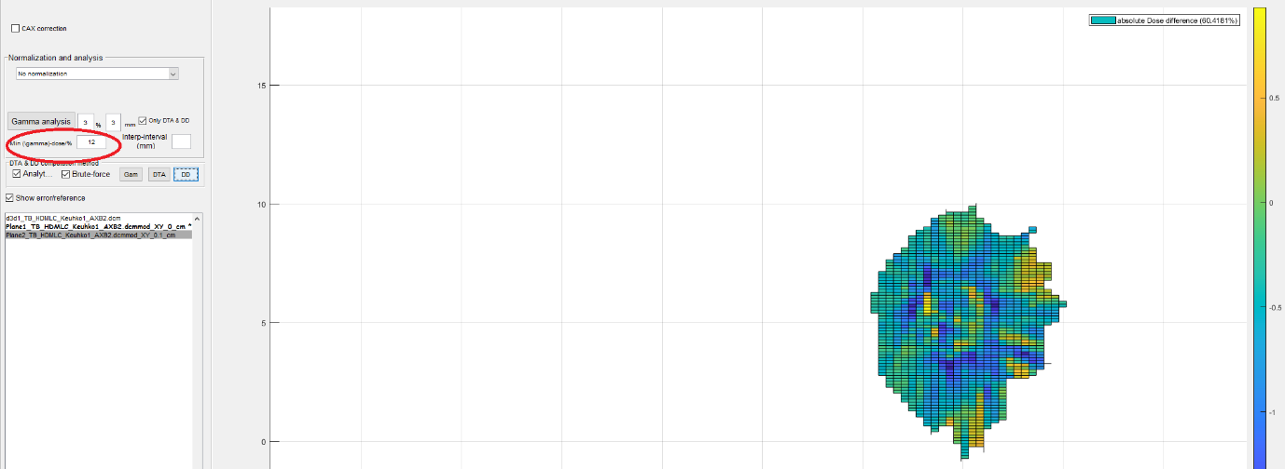

***Figure 17.*** *DD analysis using the isodose limit*

## Performing a gamma, DTA and DD analysis

Choose reference and target data from the listbox by clicking them. First chosen data is assigned as the reference. If you wish to compute only DTA and DD, leave the checkbox ‘only DTA/DD’ chosen. If unchecked -> gamma parameter will be computed additionally to DTA and DD.

For **1D** gamma (Geurts, 2014), DTA and DD curves are presented after computation and the results (pass percentage) will be presented in the figure legend. The results and computed data are saved in the reference data structure. DTA and DD results and data are exported as CSV, when .CSV export is used.

For **2D** data gamma index (Geurts, 2014), DTA and DD are computed either from raw data (‘low resolution’ unchecked) or from low resolution data (‘low resolution’ checked). Consider low resolution computation for speed for large files. Gamma, DTA and DD computation results are displayed by clicking a corresponding checkbox (‘gam’, ‘DTA’, ‘DD’). Note that gamma, DTA and DD results are activated only for the **reference data** after 2D gamma computation. Gamma data and results are saved to the reference structure, which can be saved in the MATLAB workspace folder. Unlike in 1D case, the gamma data is not exported as CSV, but only the gamma computation results (pass percentage for gamma index, DTA and relative DD).

Each data structure may contain multiple gamma results (user prompt).

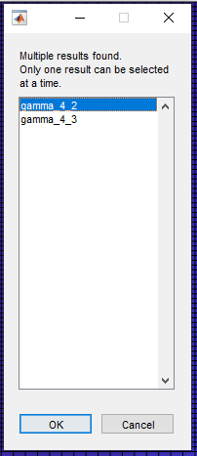

***Figure 18.*** *User prompt for multiple gamma results*

# Saving the data and results

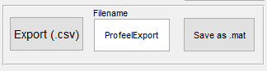

***Figure 19.*** Data export buttons

Data can be saved as .mat file. The saved file is a structure set, containing all imported and computed data.

1D data, gamma, DTA and DD results can be exported as .CSV file. New exports with same filenames won’t append existing files but create a new file with indexed filename: “filename_n”.

REFERENCES

Geurts, Mark. 2014. CalcGamma() MATLAB-function. Available at: https://github.com/mwgeurts/gamma